Lincon Woodruff
CS330
Professor
12 September, 2026
CS 330 Final Project Proposal
For my final project, I will recreate a simple desk scene containing a desk lamp, a closed book, a coffee mug, and a small potted plant. The objects will rest on a desk surface that serves as the ground plane. I selected this scene because it contains several recognizable household objects while still remaining practical to model with the primitive meshes provided in the course. The scene also gives me opportunities to demonstrate transformations, texture mapping, lighting, and camera control without requiring overly complex custom geometry.
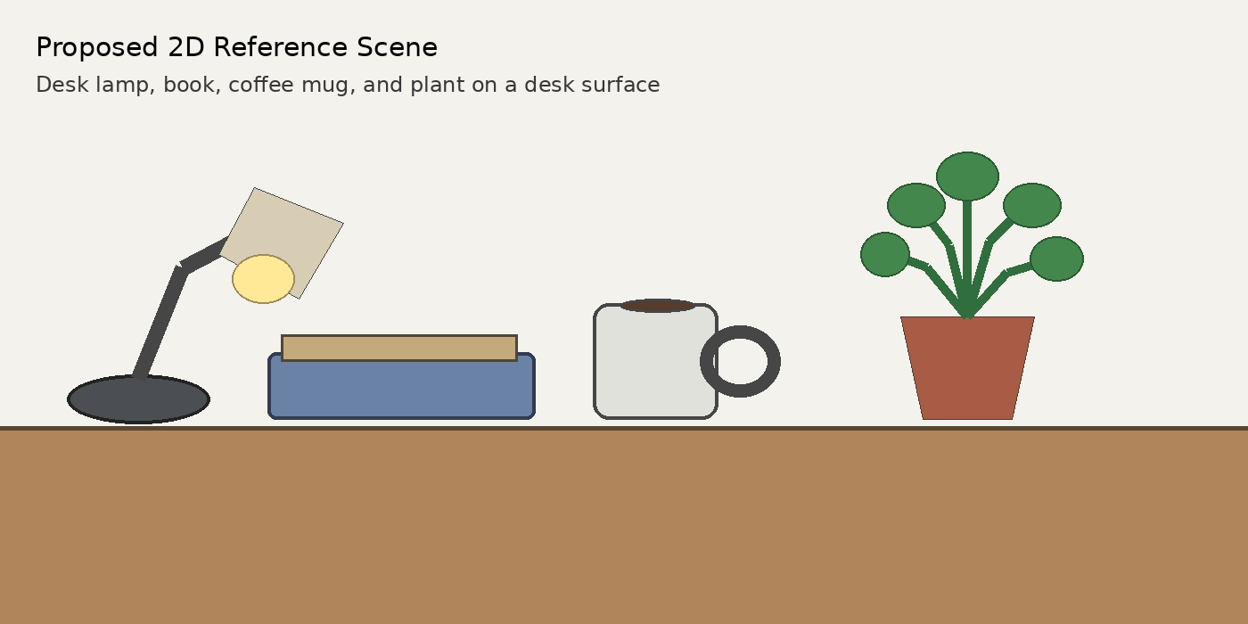
Figure 1. Proposed desk scene sketch created for this project proposal.
The four primary objects will be the lamp, book, coffee mug, and plant. These items are a good choice because each has a distinct silhouette and can be recognized even when simplified. The lamp and mug also allow multiple basic meshes to be combined into a single object, which will make the finished scene more visually interesting. The book provides a straightforward rectangular object for applying a texture, while the plant adds a more organic form that contrasts with the other objects.
A plane will be used for the desktop and will ground the rest of the scene. The book will be created from a scaled box. The coffee mug will use a cylinder for the cup body and a torus for the handle. The lamp will combine cylinders for its base and support arm with a cone for the shade. The plant pot will use a tapered cylinder, and the plant can be approximated with small spheres or other simple primitive shapes for the leaves. This design uses at least six primitive types: plane, box, cylinder, torus, cone, and tapered cylinder, with spheres available for additional detail. Because the scene relies on simple primitives, the overall scope should remain achievable while still meeting the project requirements and providing enough variety to explore materials, textures, lighting, and perspective.

